Create Trello and Assign priority for each card design document
by Haydn Roberts
I will be using the MoSCoW method to rank the importance of the features in the Trello
Must have:
IoT device GPS location sharing
Back end code for the mobile app
Encrypted transmissions
Should have:
Appealing visual design for the mobile app
Algorithm to create boundaries based on routines
Alert function when geofence is left
Could have:
Last known location feature
Would have:
Make the mobile app work on IOS
The must have development features are key to the product and are what must be completed by our first milestone
Should have features are also very important but are to be focused on after the core of the application has been developed
Could have features are to be implemented if we still have time to improve the user experience.
Would have features are not viable for this project but would be nice additions if the project had a longer time schedule and budget (developing an IOS app costs a required $99 a year subscription)
This has been implemented into the Trello board:
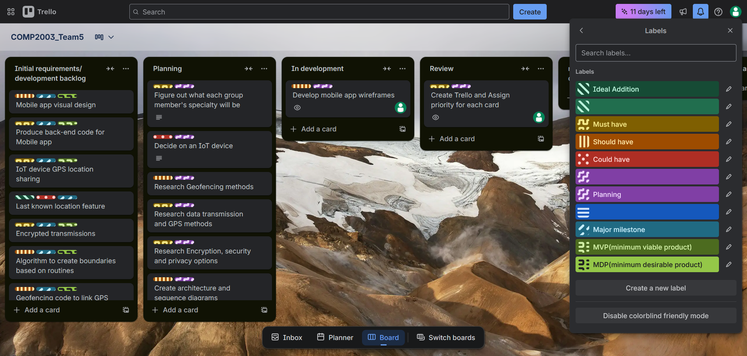
As you can see, the board is very populated, with the leftmost column being the main milestones discussed earlier in this document, followed by the planning column for all the plans that we should make for the next in person client meeting.
The card tied to this document has been assigned to my account and moved to the review column for other group members to review and give feedback to before it can be classified as a completed task
I have also assigned myself to the wireframe task as the mobile app is one of the things that I specialise in:
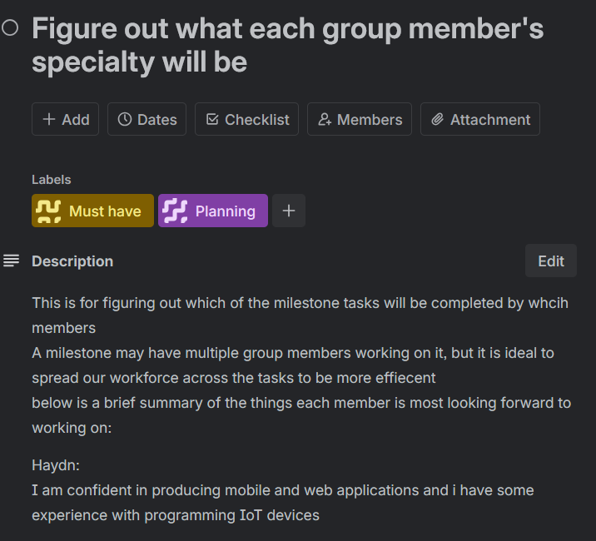
This is a system that should help us not accidentally develop the same plans twice, while still giving us the option to have multiple members work on a plan if it is deemed important enough and the members choose to allot multiple members to work on it.
This Document is intended to be a gold standard of the workflow for design documents on this project, naming the document the same as the Trello card that it is tied to, uploading it to github and crediting the members that worked in the task.

